Game Theory

Share[9](http://www.investinganswers.com/financial-dictionary/economics/game-theory-2160)

Game theory is a tool used to analyze strategic behavior by taking into account how participants expect others to behave. Game theory is used to find the optimal outcome from a set of choices by analyzing the costs and benefits to each independent party as they compete with each other.

EXAMPLE

Game theory explores the possible outcomes of a situation in which two or more competing parties look for the course of action that best benefits them. No variables are left to chance, so each possible outcome is derived from the combinations of simultaneous actions by each party.

Game theory is best exemplified by a classic hypothetical situation called the Prisoners' Dilemma. In this scenario, two people are arrested for stealing a car. They [will](http://www.investinganswers.com/node/4974) each serve 2 years in prison for their crime.

The case is air-tight, but the police have reason to suspect that the two prisoners are also responsible for a recent string of high-profile bank robberies. Each prisoner is placed in a separate cell. Each is told he is suspected of being a bank robber and questioned separately regarding the robberies. The prisoners cannot communicate with each other.

The prisoners are told that a) if they both confess to the robberies, they'll each serve 3 years for the robberies and the car theft, and b) if only one confesses to the robbery and the other does not, the one who confesses will be rewarded with a 1 [year](http://www.investinganswers.com/node/5717) sentence while the other will be punished with a 10 year sentence.

In the game, the prisoners have only two possible actions: confess to the bank robbery, or deny having participated in the bank robbery.

Since there are two players, each with two different strategies, there are four outcomes that are possible:

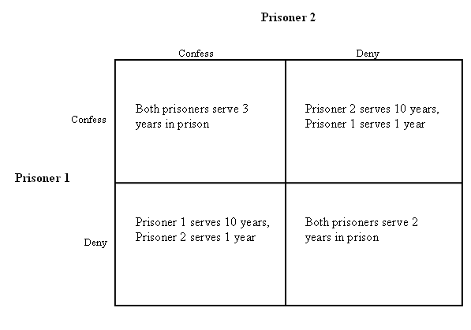

The best option for both prisoners is to deny committing the robberies and face 2 years in prison for the car theft. But because neither can be guaranteed that the other won't confess, the most likely outcome is that both prisoners will [hedge](http://www.investinganswers.com/node/345) their bets and confess to the robberies -- effectively taking the 10 year sentence off the table and replacing it with the 3 year sentence.